Kubernetes 10

- Setup EKS Cluster using eksctl
Prerequisites
- AWS CLI configured (aws configure)
- kubectl installed
- eksctl installed
- IAM user with EKS permissions

  - Install kubectl on Windows
kubectl is the Kubernetes CLI tool.

Step 1: Download kubectl
Go to:
https://kubernetes.io/docs/tasks/tools/
Download the Windows version.
Or use PowerShell:
curl.exe -LO "https://dl.k8s.io/release/v1.29.0/bin/windows/amd64/kubectl.exe"

Step 2: Move to PATH
- Move kubectl.exe to:
C:\kubectl\
- Add this folder to Environment Variables → PATH

Step 3: Verify
kubectl version --client
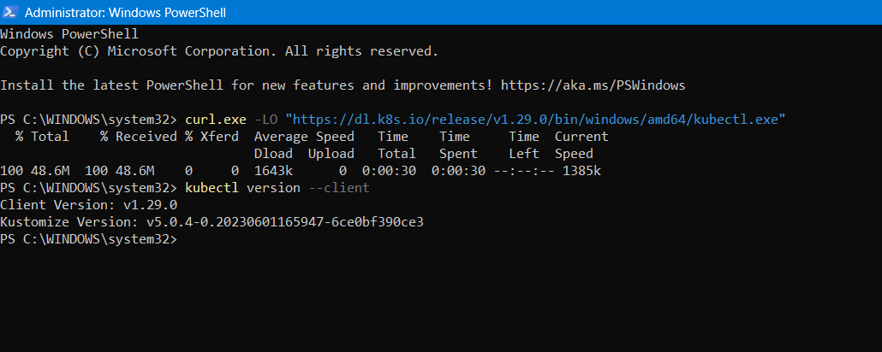

  - Install eksctl on Windows
eksctl is used to create EKS clusters easily.

Step 1: Install Chocolatey (Recommended)
Open PowerShell as Administrator and run:
Set-ExecutionPolicy Bypass -Scope Process -Force; `
[System.Net.ServicePointManager]::SecurityProtocol = `
[System.Net.ServicePointManager]::SecurityProtocol -bor 3072; `
iex ((New-Object System.Net.WebClient).DownloadString('https://community.chocolatey.org/install.ps1'))
Verify:
choco --version
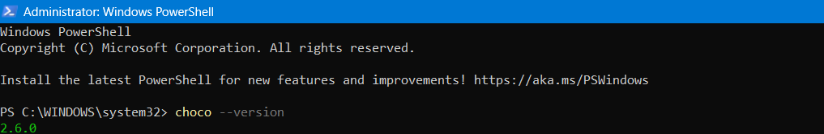
Step 2: Install eksctl
choco install eksctl -y

Step 3: Verify
eksctl version

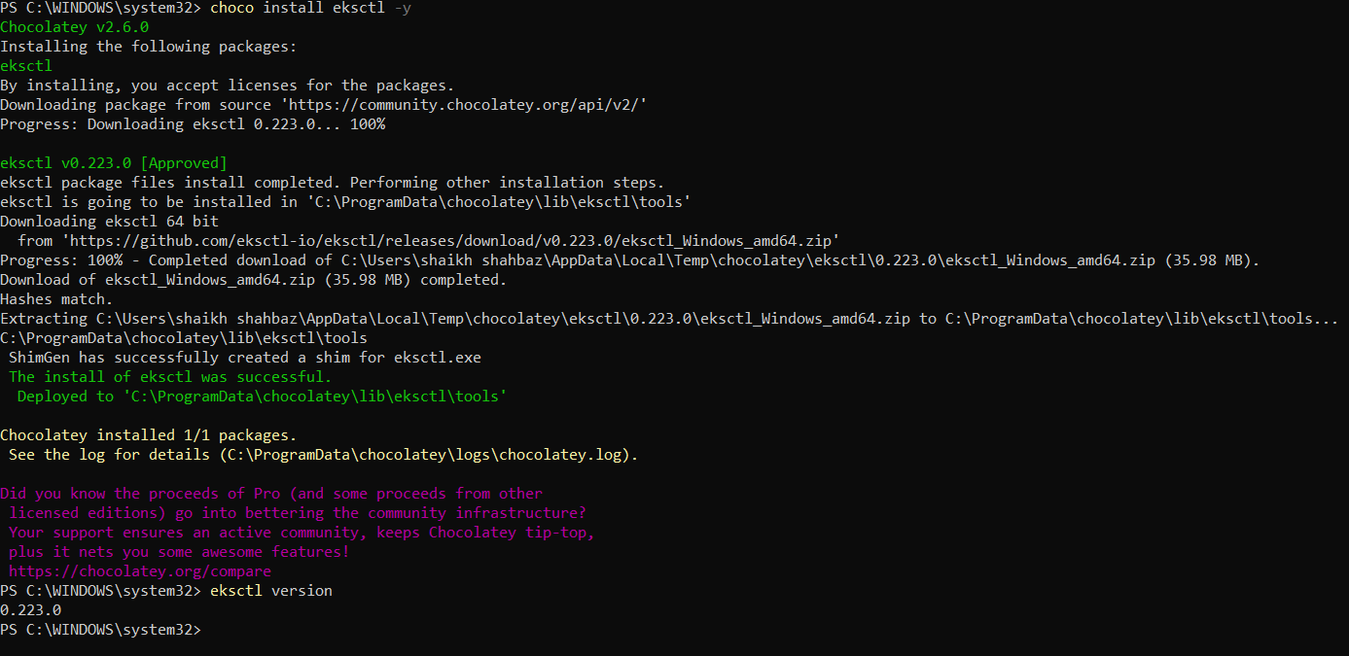

Step 1: Create EKS Cluster
eksctl create cluster \
--name my-eks-cluster \
--region us-east-1 \
--nodegroup-name ng-1 \
--node-type t3.medium \
--nodes 2 \
--nodes-min 2 \
--nodes-max 4 \
--managed
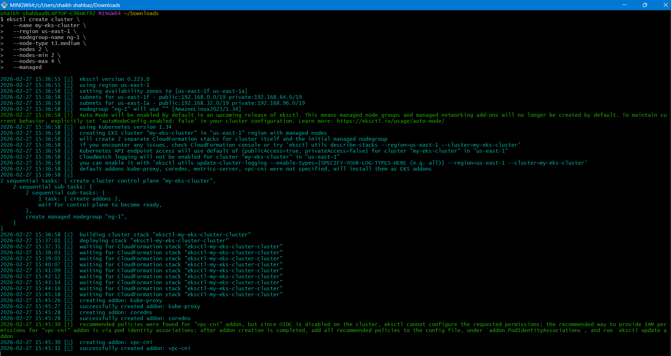
Explanation
- --managed → Creates managed node group
- --nodes-min/max → Enables autoscaling
- t3.medium → EC2 worker nodes
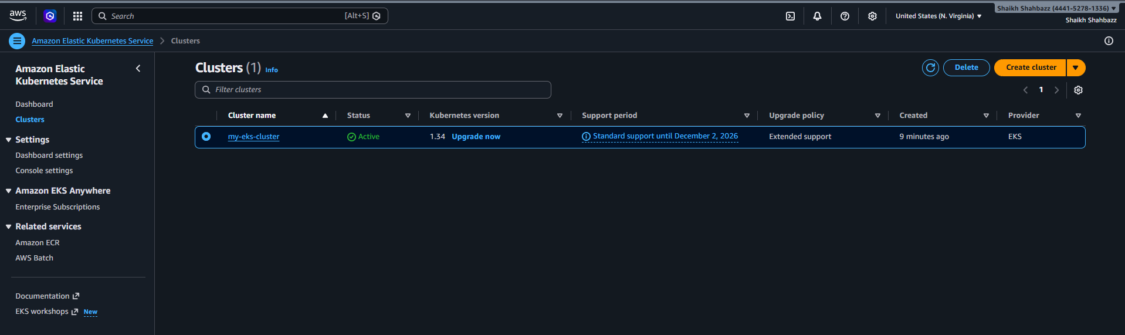
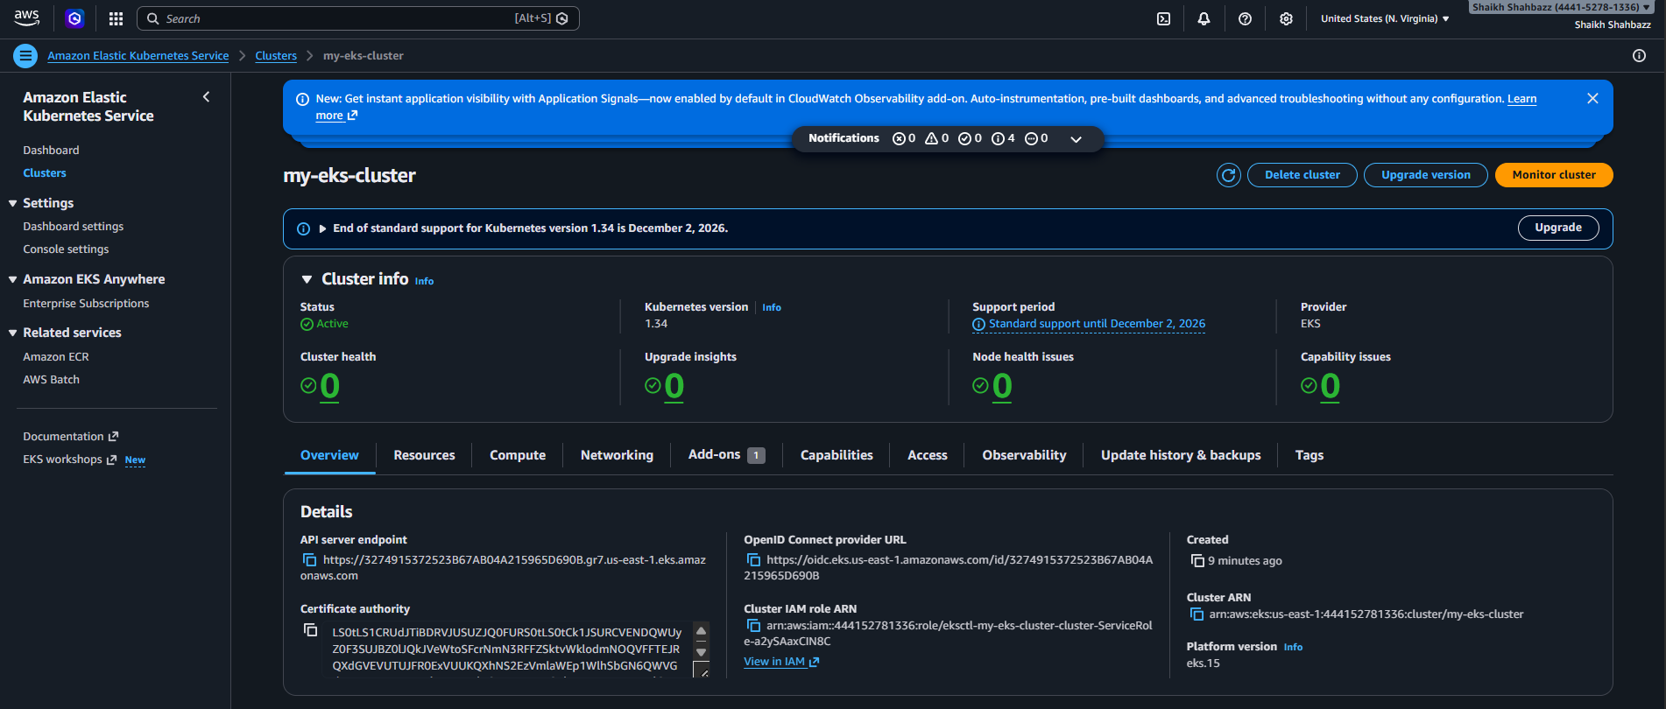
Step 2: Validate Cluster
kubectl get nodes
kubectl get pods -A
You should see:
- Nodes in Ready state
- Core system pods running in kube-system
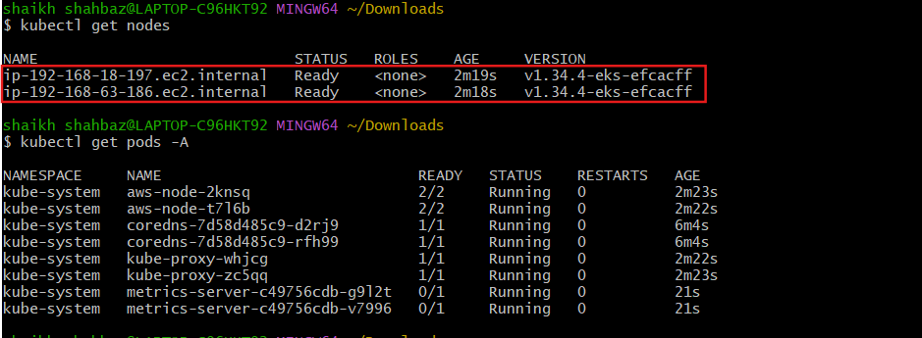

- Setup EKS Cluster using AWS Console
Step 1: Create Cluster
- Go to AWS Console → EKS → Create cluster
- Choose:
  - Name
  - Kubernetes version
  - IAM cluster role
- Configure networking (VPC, subnets)
- Create
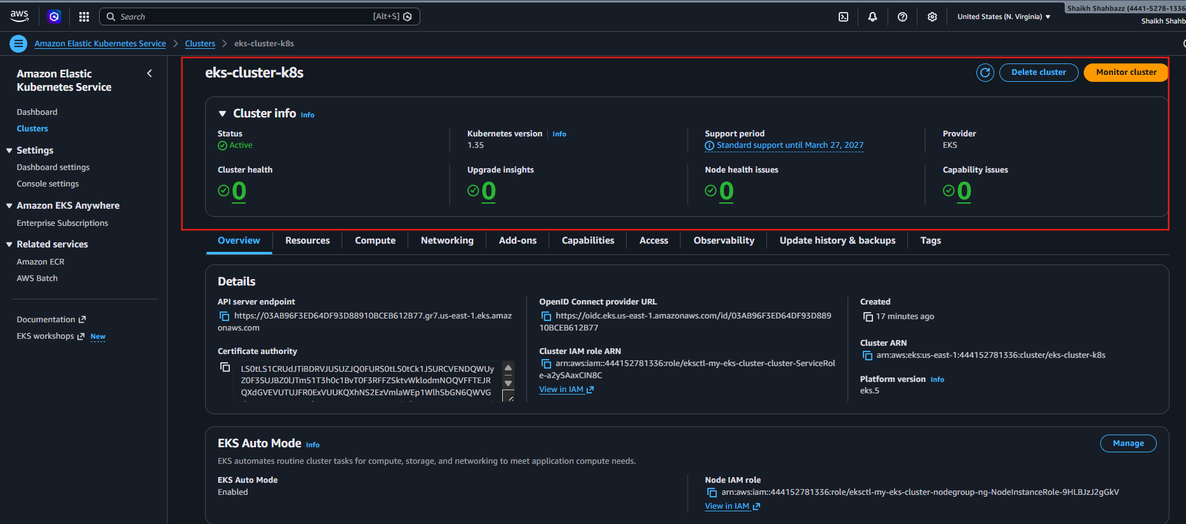
🔹 Step 2: Add Node Group
- Go to Compute → Add Node Group
- Select:
  - AMI type
  - Instance type
  - Desired capacity
  - Min/Max size
- Create
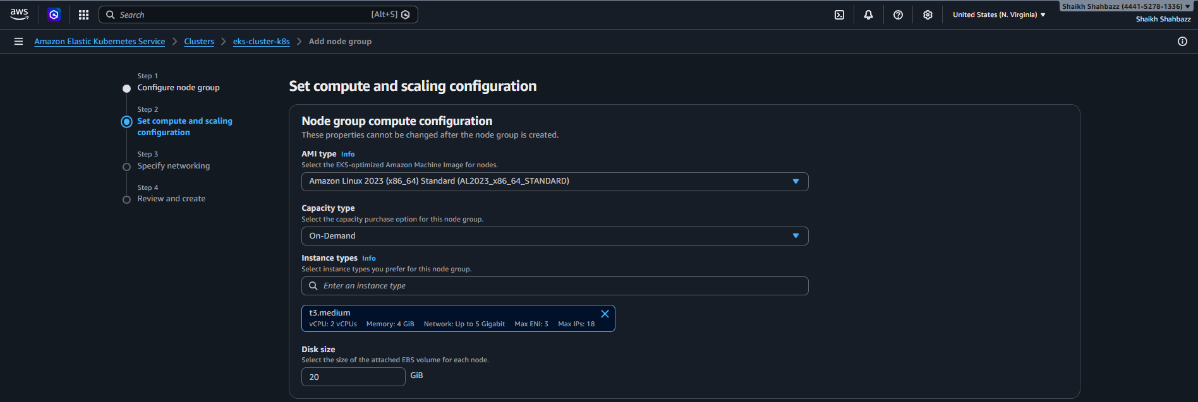
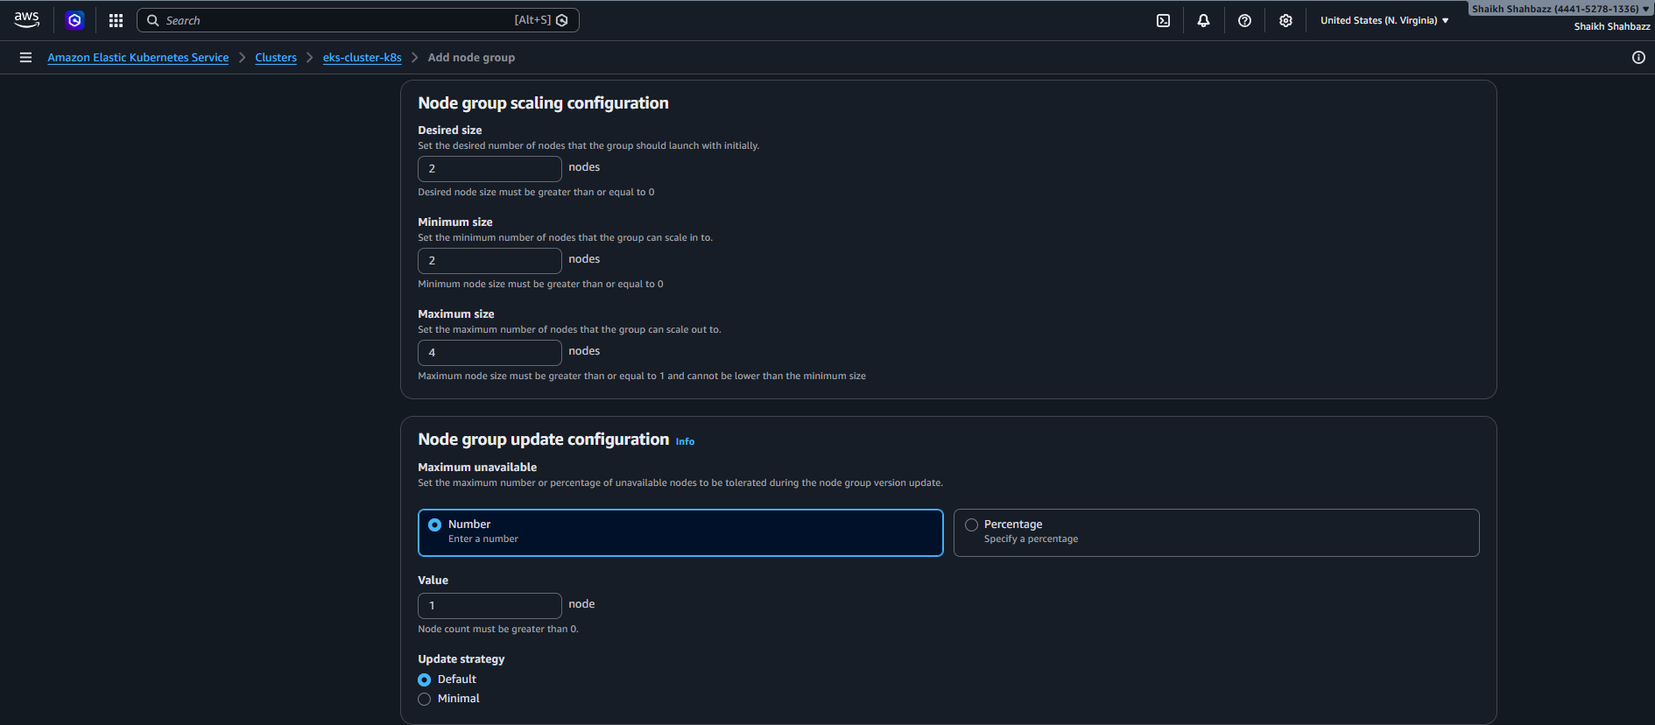
Step 3: Connect to Cluster
aws eks update-kubeconfig --region us-east-1 --name my-eks-cluster
kubectl get nodes
✅ Validation
Nodes should be in Ready state.
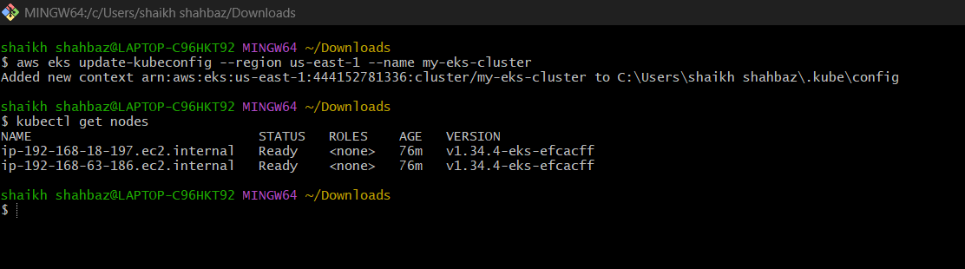

- Setup HPA (Horizontal Pod Autoscaler)
Step 1: Deploy Sample App
vi deployment.yaml
apiVersion: apps/v1
kind: Deployment
metadata:
name: nginx
spec:
replicas: 1
selector:
matchLabels:
app: nginx
template:
metadata:
labels:
app: nginx
spec:
containers:
- name: nginx
image: nginx
resources:
requests:
cpu: "100m"
limits:
cpu: "200m"
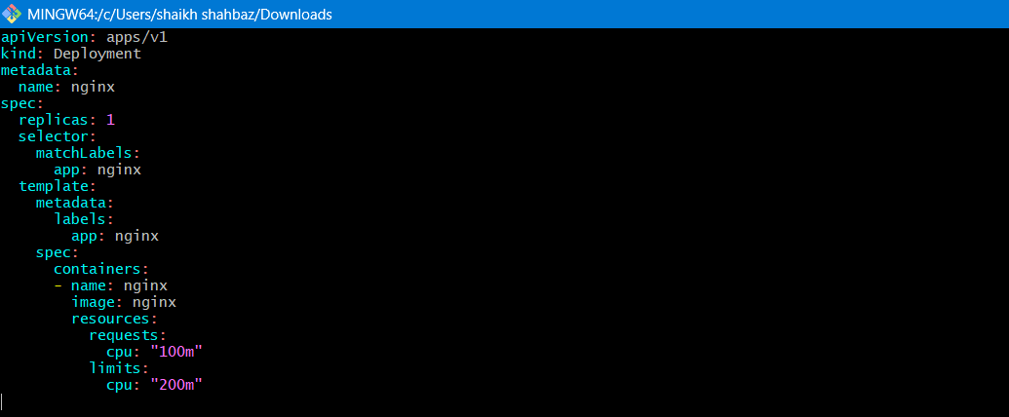
kubectl apply -f deployment.yaml
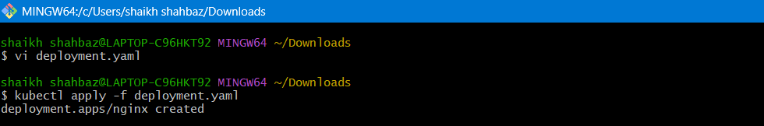
Step 2: Install Metrics Server
kubectl apply -f https://github.com/kubernetes-sigs/metrics-server/releases/latest/download/components.yaml
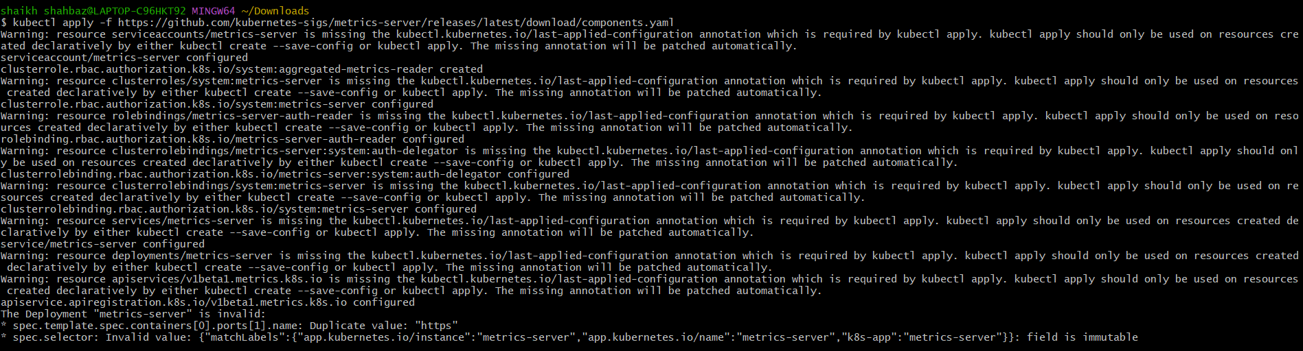
Step 3: Create HPA
kubectl autoscale deployment nginx --cpu-percent=50 --min=1 --max=5
Validation
kubectl get hpa
kubectl top pods
Generate load → replicas should increase.
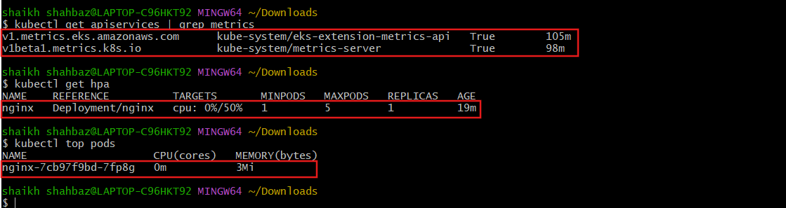

- Setup Cluster Autoscaler

STEP 1 — Verify Node Group Scaling Range
Go to:
EC2 → Auto Scaling Groups
Select your node group ASG.
Check:
- Min capacity
- Desired capacity
- Max capacity
For example:
Min = 2
Desired = 2
Max = 4
If Max is not higher than Desired, increase it.
Autoscaler cannot scale beyond Max.
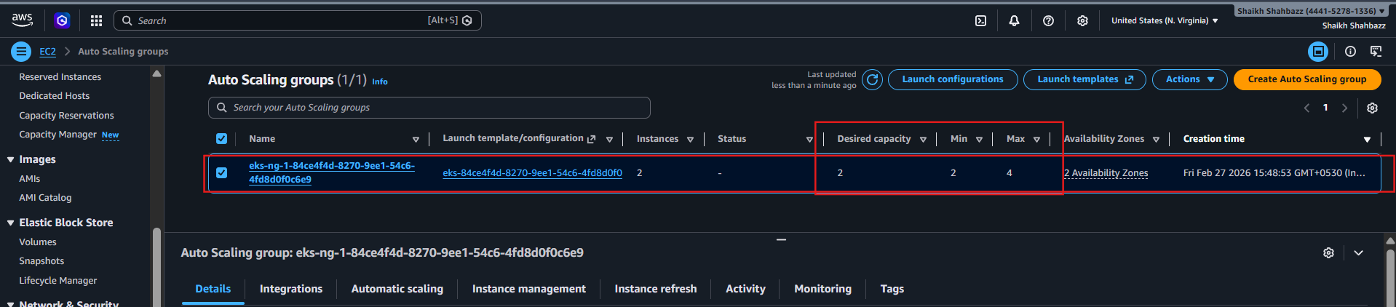

STEP 2 — Tag Auto Scaling Group (VERY IMPORTANT)
Still inside Auto Scaling Group → Tags → Add tags:
Add:
Key: k8s.io/cluster-autoscaler/my-eks-cluster
Value: owned
Add:
Key: k8s.io/cluster-autoscaler/enabled
Value: true
✔ Check “Apply to instances”
This step is mandatory.
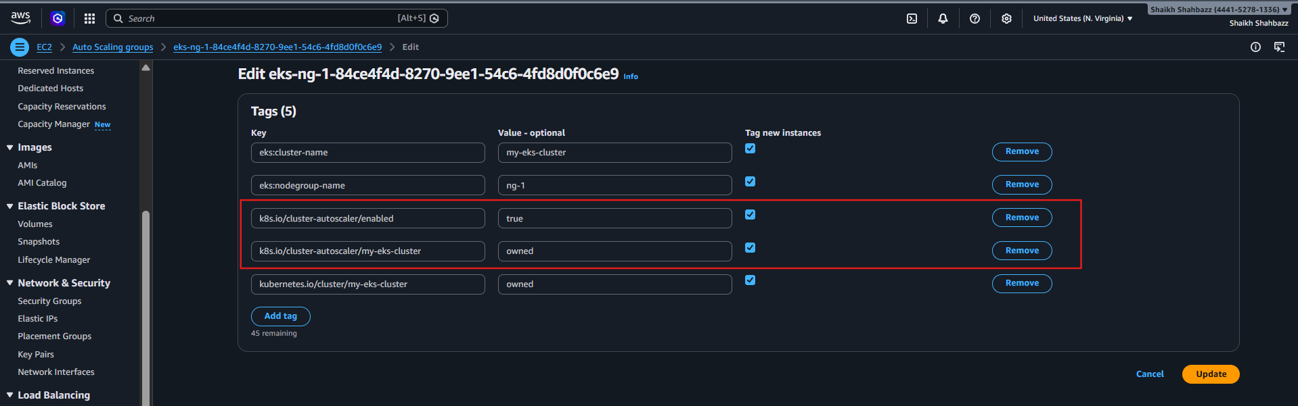
STEP 3 — Create IAM Policy (GUI Method)
Go to:
IAM → Policies → Create Policy → JSON
Paste:
{
"Version": "2012-10-17",
"Statement": [
{
"Action": [
"autoscaling:DescribeAutoScalingGroups",
"autoscaling:DescribeAutoScalingInstances",
"autoscaling:DescribeLaunchConfigurations",
"autoscaling:DescribeTags",
"autoscaling:SetDesiredCapacity",
"autoscaling:TerminateInstanceInAutoScalingGroup",
"ec2:DescribeLaunchTemplateVersions"
],
"Resource": "*",
"Effect": "Allow"
}
]
}

Name:
AmazonEKSClusterAutoscalerPolicy
Create it.
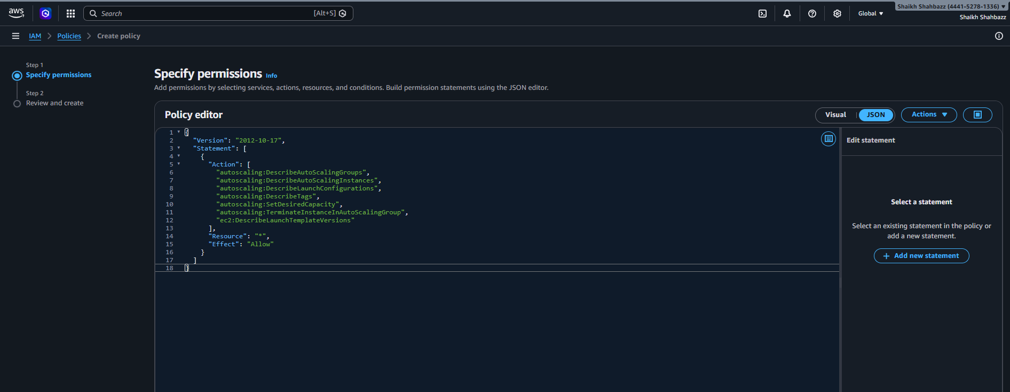
STEP 4 — Ensure OIDC Provider Exists
Run:
eksctl utils associate-iam-oidc-provider \
--region us-east-1 \
--cluster my-eks-cluster \
--approve
If it says already exists → good.
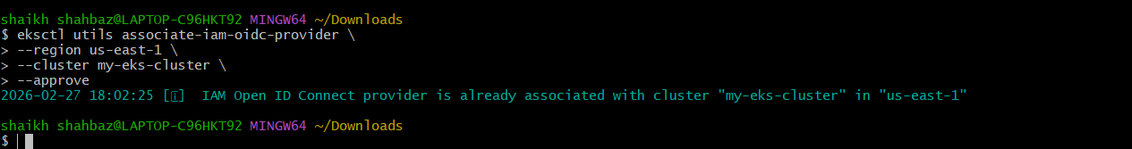
STEP 5 — Create IAM Service Account (Easiest Way)
Now run:
eksctl create iamserviceaccount \
--cluster=my-eks-cluster \
--namespace=kube-system \
--name=cluster-autoscaler \
--attach-policy-arn=arn:aws:iam::<ACCOUNT-ID>:policy/AmazonEKSClusterAutoscalerPolicy \
--override-existing-serviceaccounts \
--approve \
--region us-east-1
Replace <ACCOUNT-ID> with yours.
This automatically:
✔ Creates IAM Role
✔ Attaches policy
✔ Links Kubernetes service account
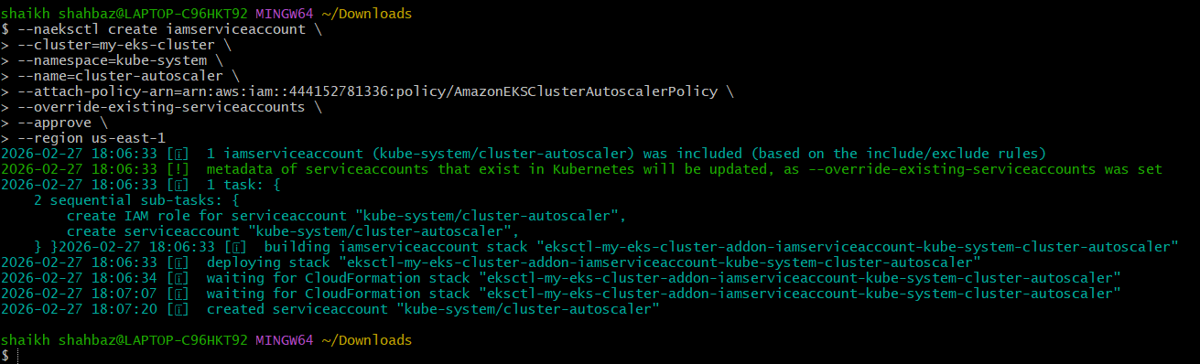
STEP 6 — Deploy Cluster Autoscaler
Download:
curl -O https://raw.githubusercontent.com/kubernetes/autoscaler/master/cluster-autoscaler/cloudprovider/aws/examples/cluster-autoscaler-autodiscover.yaml
Edit this line:
--cluster-name=<YOUR CLUSTER NAME>
Change to:
--cluster-name=my-eks-cluster
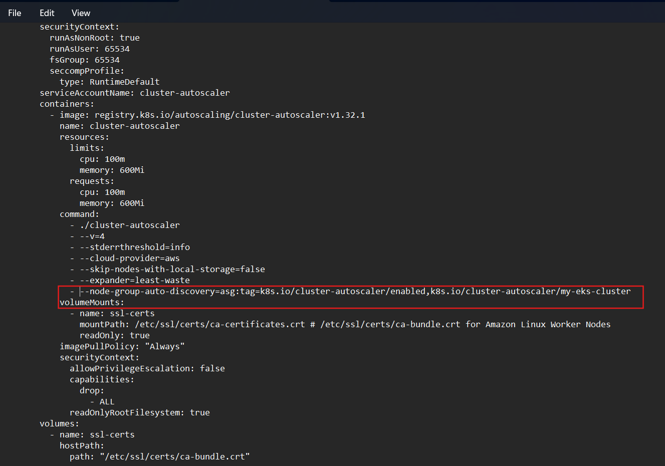
Then apply:
kubectl apply -f cluster-autoscaler-autodiscover.yaml
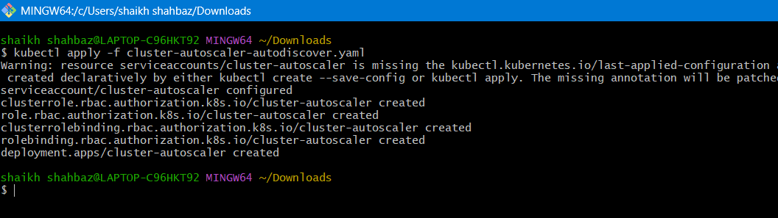
STEP 7 — Verify
Check pod:
kubectl get pods -n kube-system | grep cluster-autoscaler
Check logs:
kubectl logs -n kube-system deployment/cluster-autoscaler
You should see:
Cluster Autoscaler initialized
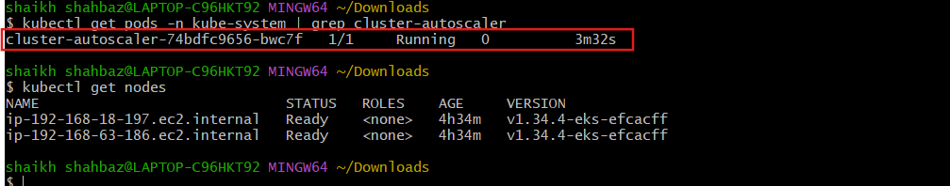
TEST IT (Very Important for Your Task Submission)
Create heavy workload:
kubectl create deployment load-test --image=nginx --replicas=20
Check pods:
kubectl get pods
Some will go into:
Pending
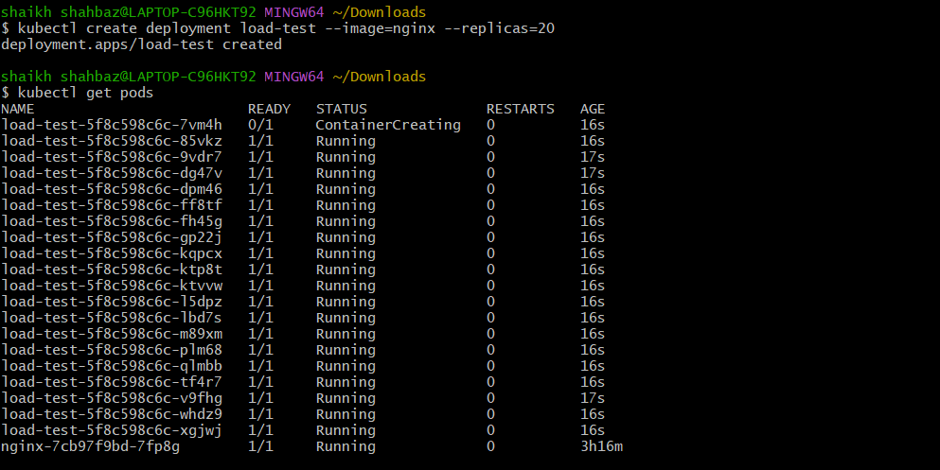
Now check nodes:
kubectl get nodes
Within 1–2 minutes, new EC2 instance should launch.
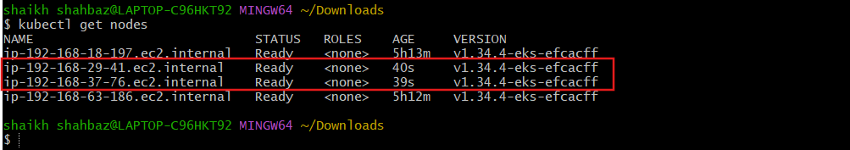
You can also verify in:
EC2 → Instances
or
Auto Scaling Group → Desired capacity increases.
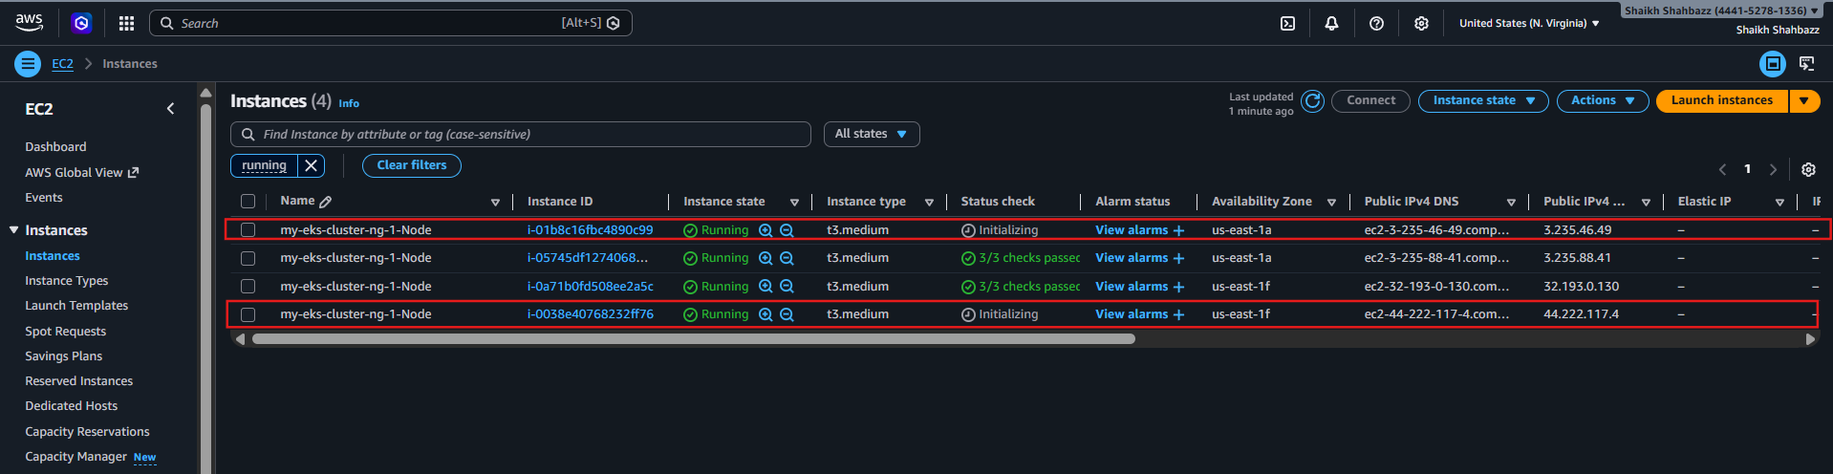
After Testing
Delete workload:
kubectl delete deployment load-test
After ~10 minutes nodes will scale down.
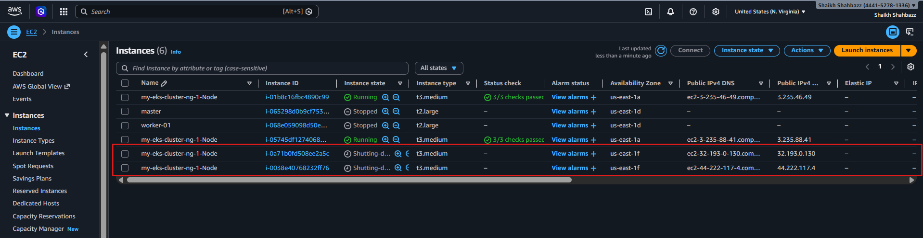
- Setup CronJob and Job
Job Example
vi job.yaml
apiVersion: batch/v1
kind: Job
metadata:
name: pi-job
spec:
template:
spec:
containers:
- name: pi
image: perl
command: ["perl", "-Mbignum=bpi", "-wle", "print bpi(2000)"]
restartPolicy: Never
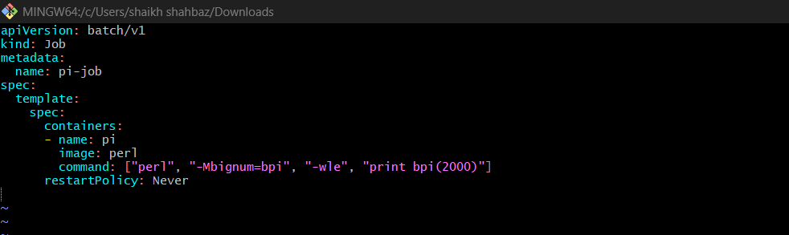
kubectl apply -f job.yaml
Validation
kubectl get jobs
kubectl logs job/pi-job
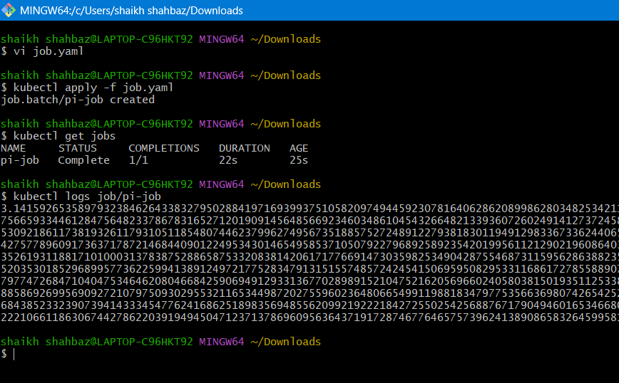
CronJob Example
vi cronjob.yaml
apiVersion: batch/v1
kind: CronJob
metadata:
name: hello-cron
spec:
schedule: "*/2 * * * *"
jobTemplate:
spec:
template:
spec:
containers:
- name: hello
image: busybox
command: ["/bin/sh", "-c", "date"]
restartPolicy: OnFailure
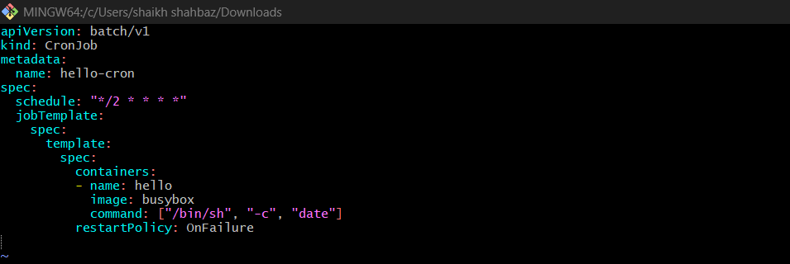
kubectl apply -f cronjob.yaml
Validation
kubectl get cronjobs
kubectl get jobs --watch
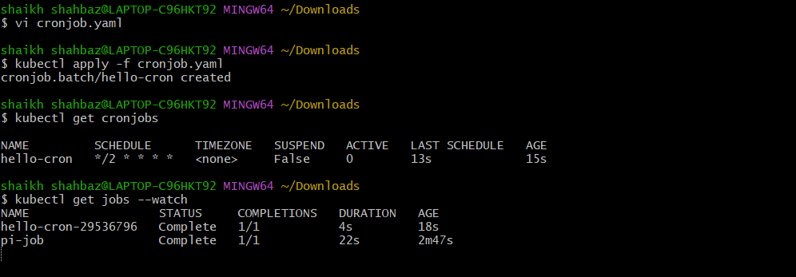
- Create Secret and Inject Inside Pod
Step 1: Create Secret
kubectl create secret generic db-secret \
--from-literal=username=admin \
--from-literal=password=pass123
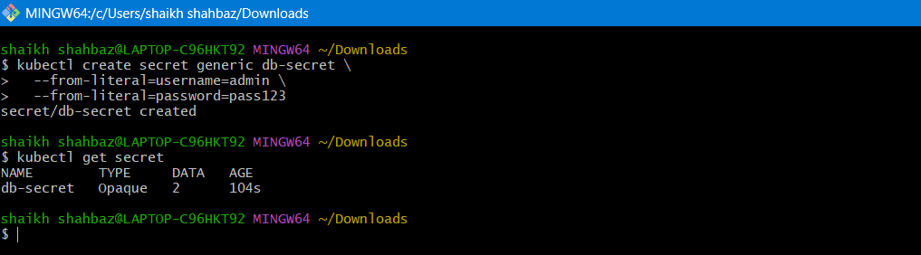
STEP 2 — Use Secret as Environment Variables (Full Pod YAML)
Create a file:
vi secret-pod.yaml
Paste this:
apiVersion: v1
kind: Pod
metadata:
name: secret-env-pod
spec:
containers:
- name: nginx
image: nginx
env:
- name: DB_USER
valueFrom:
secretKeyRef:
name: db-secret
key: username
- name: DB_PASS
valueFrom:
secretKeyRef:
name: db-secret
key: password
Save → Close
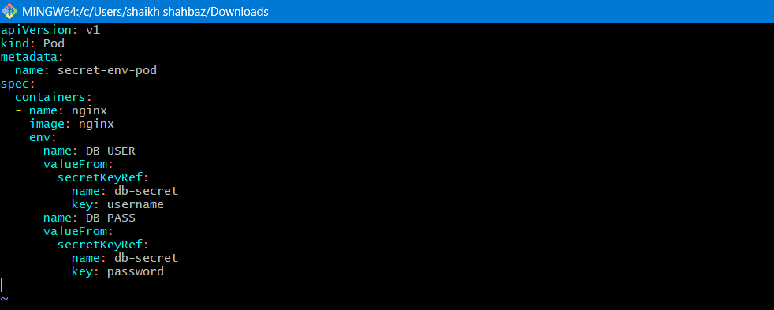
Apply:
kubectl apply -f secret-pod.yaml

Validate (Environment Variable)
kubectl exec -it secret-env-pod -- env | grep DB
Output should be:
DB_USER=admin
DB_PASS=pass123
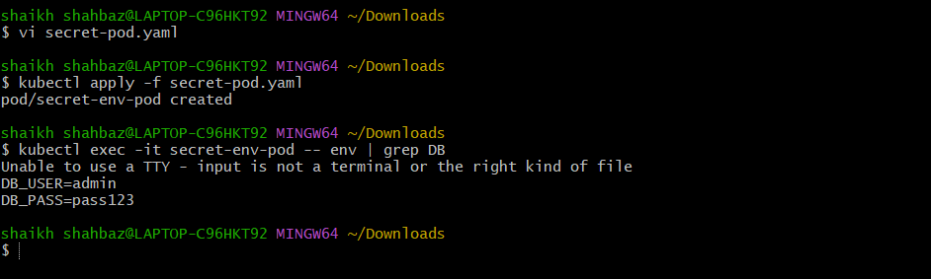

- Different Add-ons Available on EKS
Go to:
AWS Console → EKS → Add-ons
Common add-ons:
Add-on | Purpose
VPC CNI | Pod networking
CoreDNS | DNS resolution
kube-proxy | Networking proxy
EBS CSI Driver | Persistent volumes
EFS CSI Driver | Shared file storage
AWS Load Balancer Controller | ALB/NLB integration
Metrics Server | Resource metrics
Cluster Autoscaler | Node autoscaling

Validation
kubectl get pods -n kube-system
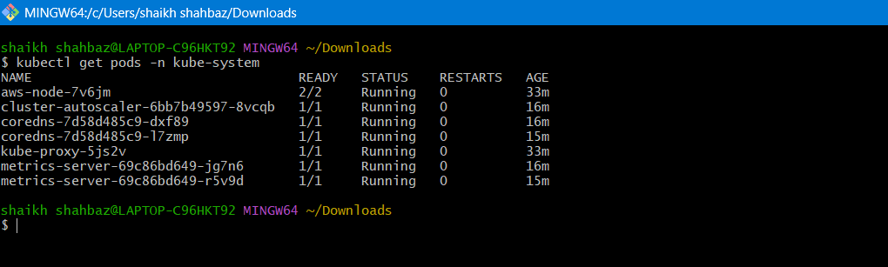

- Upgrade EKS Cluster
Step 1: Check Current Version
eksctl get cluster --name my-eks-cluster --region us-east-1
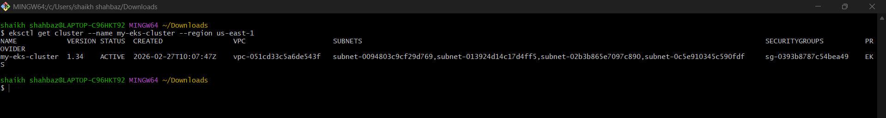
Step 2: Check Available Kubernetes Versions
eksctl utils describe-cluster-versions --region us-east-1
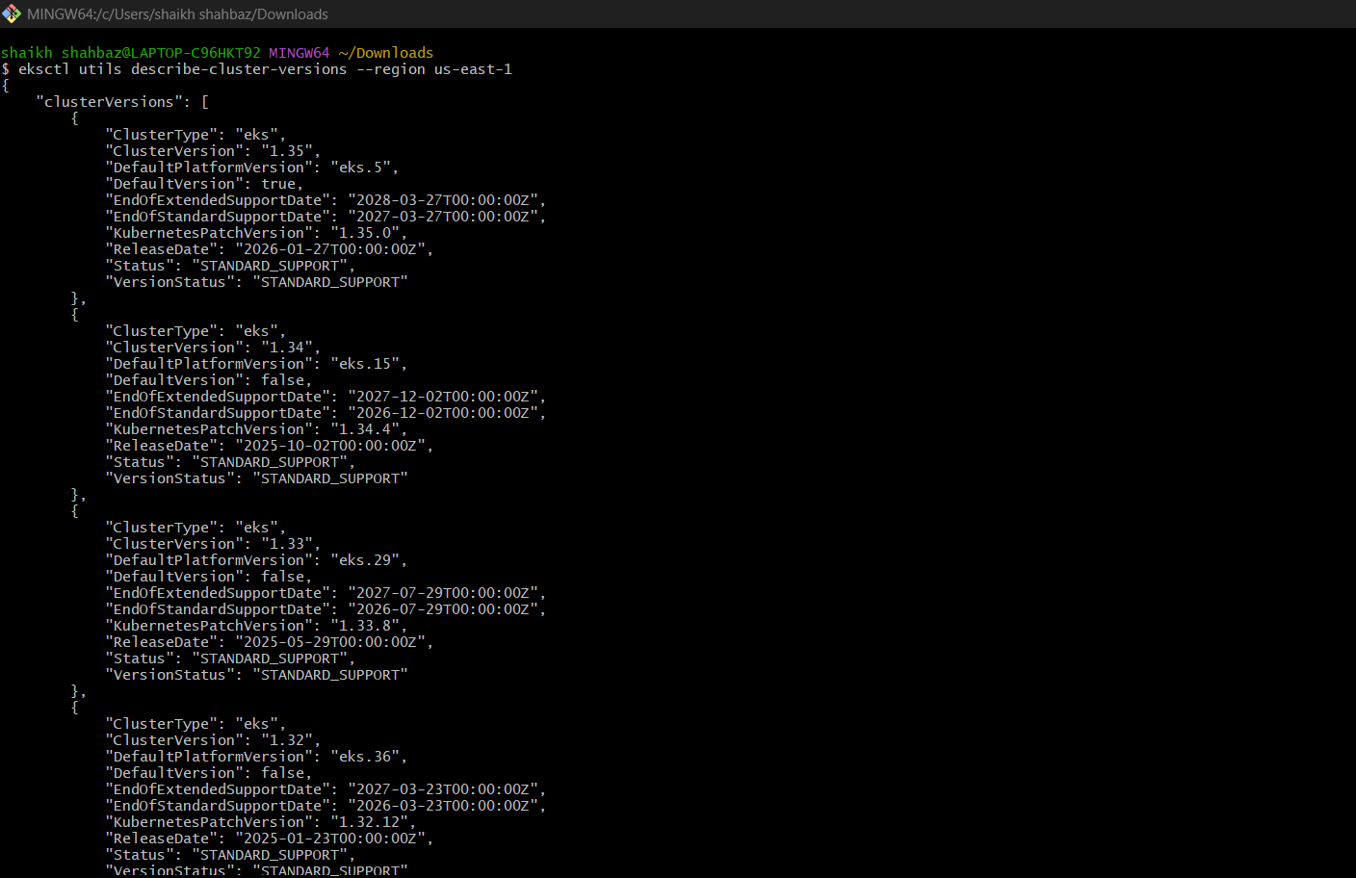
Step 3: Upgrade Control Plane (IMPORTANT)
First run plan:
eksctl upgrade cluster \
--name my-eks-cluster \
--region us-east-1
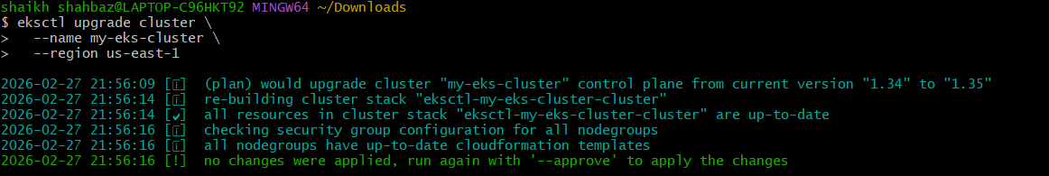
Then actually upgrade:
eksctl upgrade cluster \
--name my-eks-cluster \
--region us-east-1 \
--approve
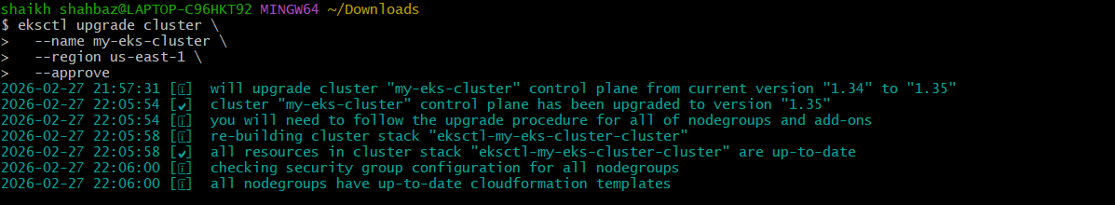

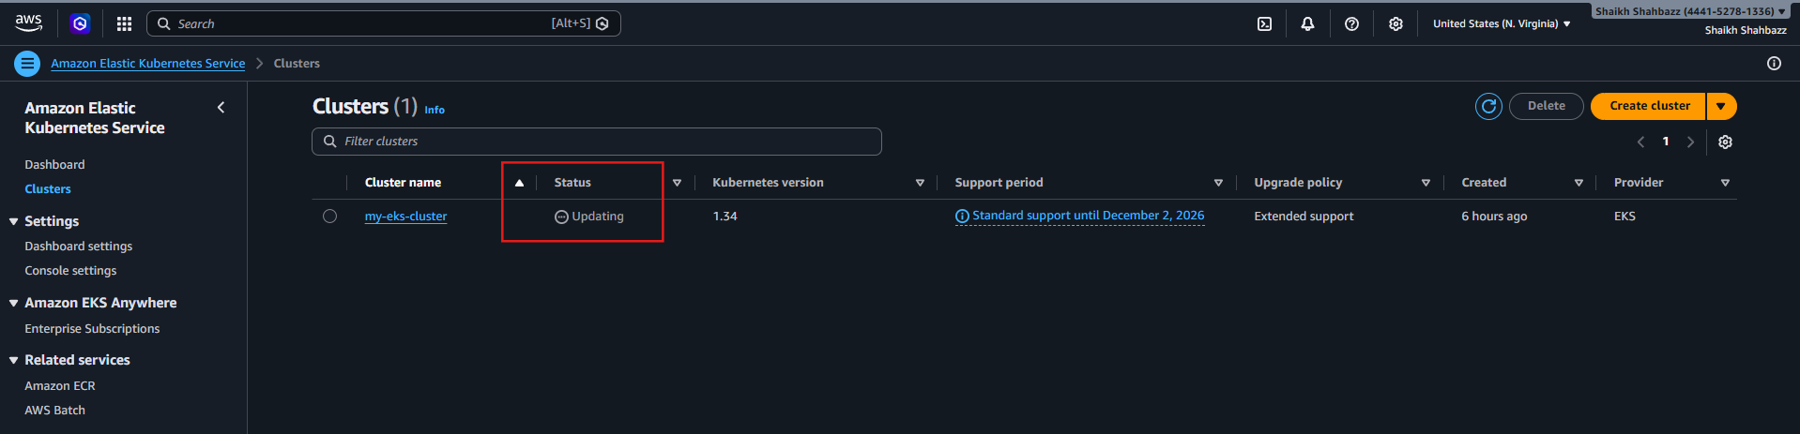
Wait until upgrade completes.
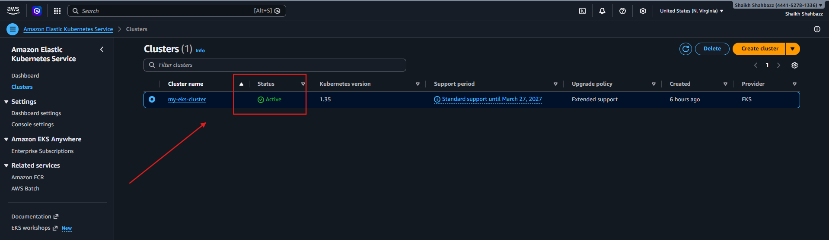
Step 4: Upgrade Nodegroup
After control plane upgrade finishes:
eksctl upgrade nodegroup \
--cluster my-eks-cluster \
--name ng-1 \
--region us-east-1
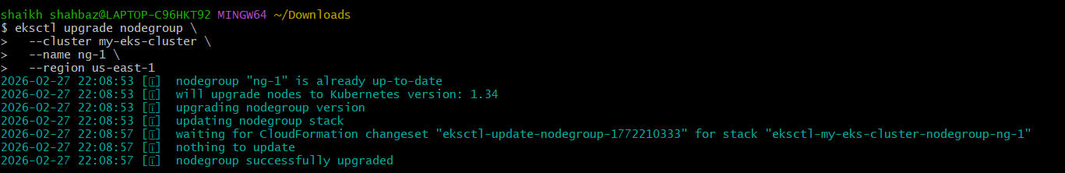
Verify:
kubectl get nodes
Nodes should show new version.
Step 5: Upgrade Managed Addons
Since your addons are managed, use:
Update VPC CNI
eksctl update addon \
--cluster my-eks-cluster \
--name vpc-cni \
--region us-east-1
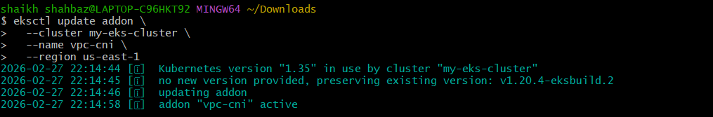
Update CoreDNS
eksctl update addon \
--cluster my-eks-cluster \
--name coredns \
--region us-east-1
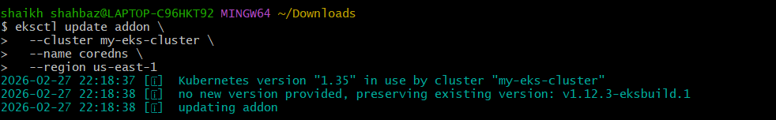
Update kube-proxy
eksctl update addon \
--cluster my-eks-cluster \
--name kube-proxy \
--region us-east-1
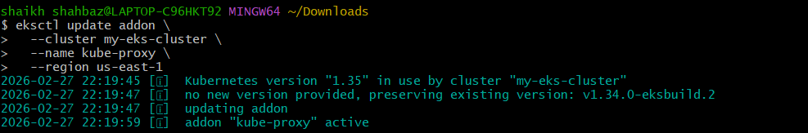

Step 6: Final Validation
kubectl get nodes
kubectl get pods -n kube-system
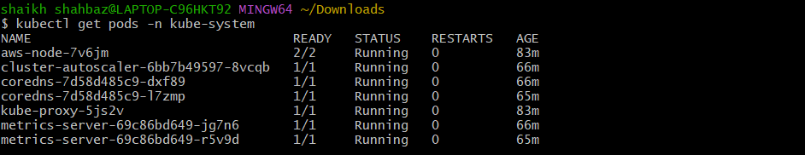
eksctl get addons --cluster my-eks-cluster --region us-east-1
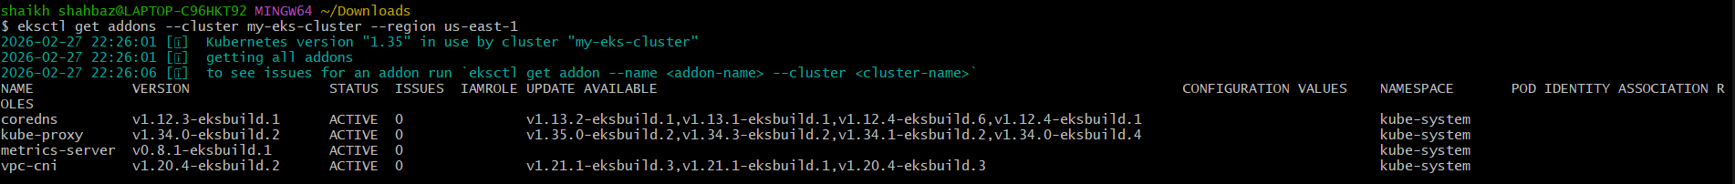
Everything should be:
- Nodes Ready ✅
- Pods Running ✅
- Addons Active ✅
